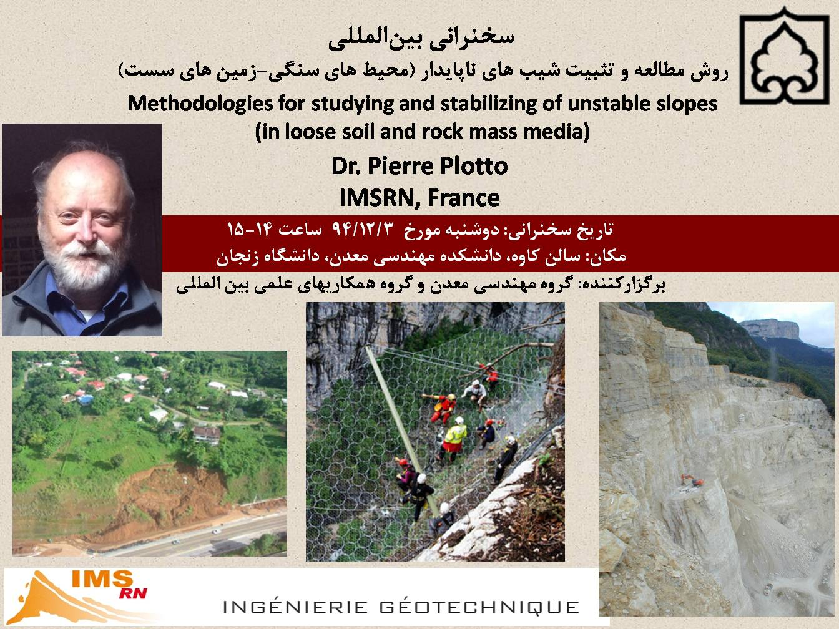
A scientific lecture entitled "Methodologies for Studying and Stabilizing of Unstable Slopes (in loose soil and rock mass media)" by Dr. Pierre Plotto, President at IMSRN from France, was held by the Department of Mining Engineering and International Scientific Cooperation Department on February 22, 2016.
At the beginning of the meeting, Dr. Rafiei, head of the Mining Engineering Department, introduced Dr. Plotto and the IMSRN Company. He also highlighted the importance of international communication, especially in order to gain experience alongside academic work. Furthermore, he mentioned the purpose of French company’s presence in the University of Zanjan, which is mostly related to research and developmental collaboration with professors and students of the university.
Then Dr. Plotto initiated his lecture on the experiences and practical solutions proposed by the company for different hazards which are created in the environment of unstable soil and rock slopes. Lecture was started with numerous examples of large slips occurred all around the world and the main reasons for occurrence of the events were described one by one. He explained some new ways of measuring and monitoring unstable slopes and also cited the decisive and important role of experience besides the use of new techniques. Meanwhile, new ways were discussed about slopes and the use of scientific software for the relevant calculations. Finally, he was responsive to the questions of teachers and students who were present in the meeting.

