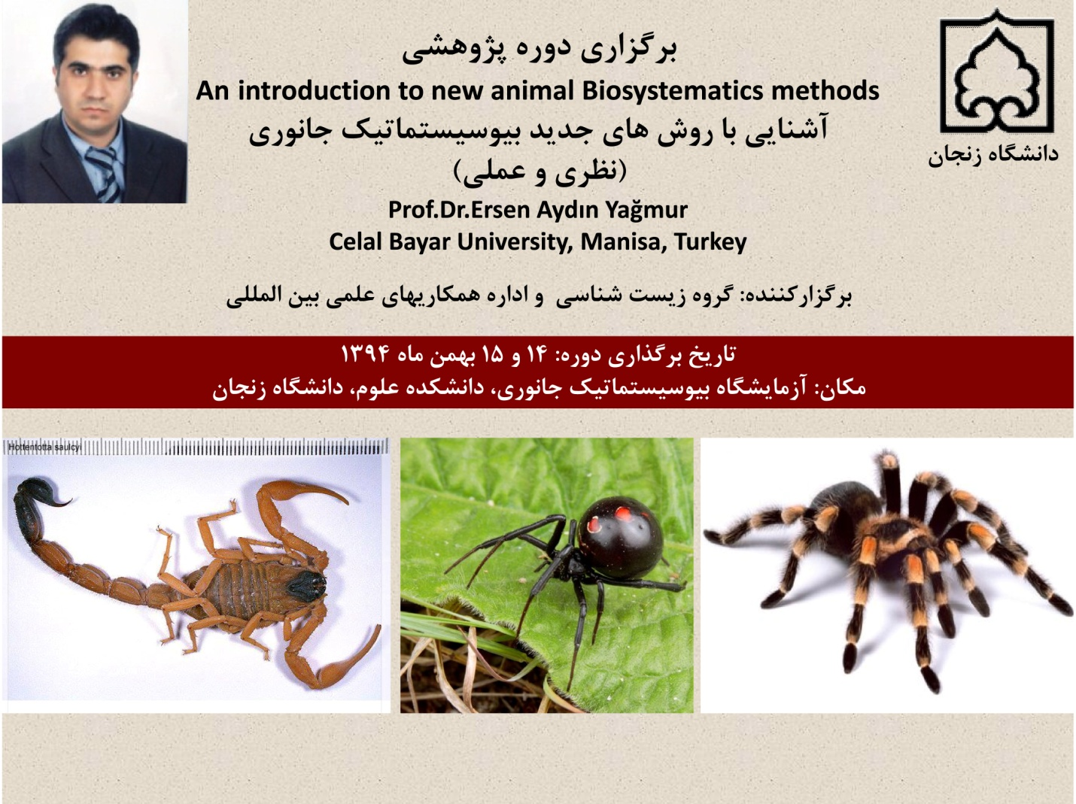
Report of Professor Ersen Aydın Yağmur’ s research course in Biology Department, Faculty of Science
Research workshop entitled “An Introduction to Modern Methods of Animal Biosystematics” was held in the Biosystematic library of biology department in two days with the presence of 16 MSc and BA students of Animal Biosystematics. Dr. Mohammad Moradi, an academic member of Biology Department, invited Professor Ersen Aydın Yağmur who is an academic member of Celal Bayar University in Turkey.
First, Dr. Moradi introduced Prof. Yağmur to the students and he also explained main purposes of the course. Then Prof. Yağmur described some generalities about arthropods (trilobite) and diagnostic criteria about their orders, families, genera and species by the help of new methods of Biosystematics.
In addition, Prof. Yaghmur taught five new methods of invertebrates’ Biosystematics as theory and practice. Followings are the methods:
- Introduction of a new method about Morphological studies of invertebrates.
- Introduction of a new method about Morphometry studies of invertebrates.
- Introduction of a new method about Cariological studies of invertebrates.
- Introduction of new methods about DNA analysis used in the preparation of phylogenetic trees.
- Introduction of new methods about DNA analysis used in the preparation of phylogenetic trees.

