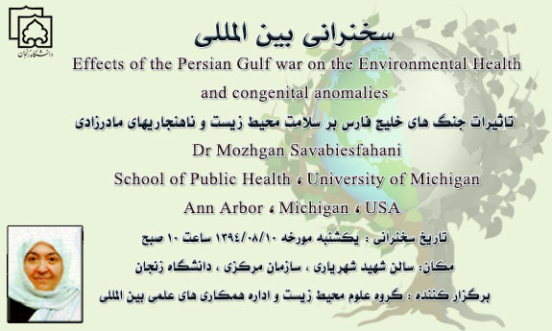
The abstract of Dr. Savabieasfahani’s lecture:

Dr Mozhgan Savabieasfahani is the winner of Rachel Carson Prize for 2015. She is the author of more than 30 peer reviewed articles and a book entitled "Pollution and Reproductive Damage: Pollution induced cell-death and reproductive damage in fish and mammals" (2009). She is an environmental toxicologist, based in Ann Arbor, Michigan. U.S.
Wars in the Middle East turned her attention to war-related pollutants and their effects on civilians. Her early research included studies of endocrine disrupting compounds and petrochemical contaminants. She has published repeatedly on the effects of war pollutants on Iraqi civilians. She has documented increases in birth defects and neurodevelopmental disorders in three Iraqi cities Basra, Fallujah, and Hawija.
She believes U.S. government and other agencies responsible for creating war pollution in Iraq and Afghanistan must be held accountable for the damage they have caused to civilians and the environment in these countries.
Dr. Savabieasfahani says: "The United States has only recently started clean up of some of its bases in Vietnam. Many U.S bases in Vietnam are severely contaminated with dioxins. Exposure to dioxins has caused birth defects and cancers in Vietnam for 40 years. Certainly the U.S. should be held responsible to clean up its bases globally. In Iraq, clean up of U.S. bases will reduce public exposure to neurotoxic compounds and reduce the catastrophic damage inflicted upon Iraq's newborns, which is already reminiscent of that in Vietnam. Why wait for decades? Cleanup now and save millions of people from years of devastation and pain".

With kind regards,
Environmental Sciences Group.

